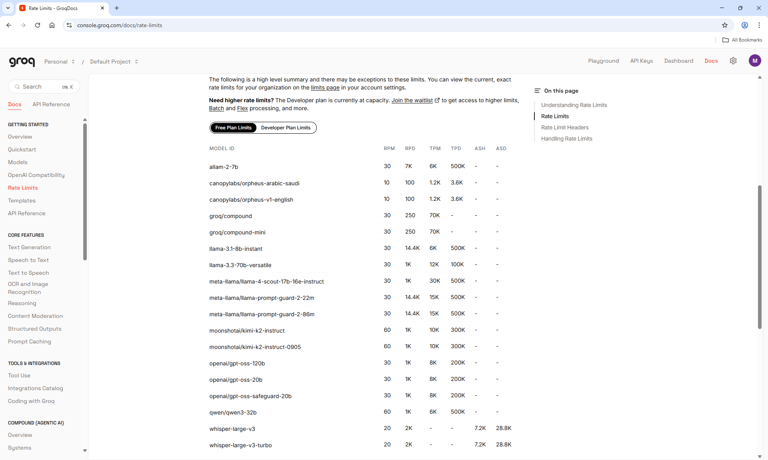

10th April 2026 – Current model llama-3.1-8b-instant

TPM Rate per minutes reached

